**Module – 2**

**Problem 1:** Import the given dataset and check for ‘NA’ values in it using the appropriate function. Now follow the given steps to manipulate your data:

Note: - **Use Data Manipulation Dataset.**

1. Create a new data frame using the given data frame (i.e. the given dataset) by removing the ‘NA’ values.
2. Consider the given dataset to replace the first NA value in the dataset with your name in that place.
3. Find the factor of each column in the dataset
4. Find the class of each column in the dataset
5. Find the structure and summary of the dataset.

Ans:-

install.packages("readr")

library(readr)

data_1 <- read.csv(file.choose())

View(data_1)

is.na(data_1)

sum(is.na(data_1))

attach(data_1)

data_1$scores

data_1$gender

data_1$admission_status

data_1$experience

data_1$scores <- as.factor(data_1$scores)

levels(data_1$scores)

data_1$gender <- as.factor(data_1$gender)

levels(data_1$gender)

data_1$experience <- as.factor(data_1$experience)

levels(data_1$experience)

data_1$admission_status <- as.factor(data_1$admission_status)

levels(data_1$admission_status)

class(data_1$experience)

class(data_1$scores)

class(data_1$gender)

class(data_1$admission_status)

str(data_1)

summary(data_1)

**Problem 2:** Use R to create the following two matrices and do the indicated matrix multiplication**.**



**Ans:-**

a <- matrix(c(7,2,9,4,12,13),nrow = 2,ncol = 3,byrow = FALSE)

View(a)

b <- matrix(c(1:3,7:9,12:14,19:21),nrow = 3,ncol = 4,byrow = F)

View(b)

c <- a%*%b

View(c)

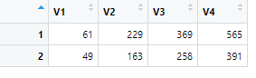

**Problem 3:** Use R to create the following two matrices and multiply each value to its successive position.

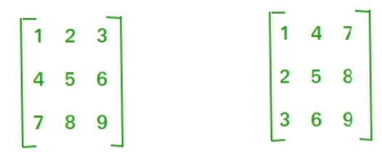

**Ans:-**

a <- matrix(c(1:9),nrow = 3,ncol = 3,byrow = T)

View(a)

b <- matrix(c(1:9),nrow = 3, ncol = 3, byrow = F)

View(b)

c <- a*b

View(c)

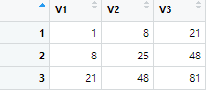

**Note:** Use R to solve the given problems in the above.